AI and Blockchain-Based System for Visual Quality Grading and Traceability of Apples in Supply Chains

Varsha Dange
Vishwakarma Institute of Technology
Pune, India varsha.dange1@vit.edu

Aditya Kachwaha
Vishwakarma Institute of Technology Pune, India aditya.kachwaha24@vit.edu
Aditi Patil
Vishwakarma Institute of Technology
Pune, India aditi.patil241@vit.edu

Abhinandan Bardia
Vishwakarma Institute of Technology Pune, India abhinandan.bardia24@vit.edu
Abhishek Patil
Vishwakarma Institute of Technology Pune, India abhishek.patil241@vit.edu

Ved Aghav
Vishwakarma Institute of Technology
Pune, India ved.aghav24@vit.edu

Abstract — A blockchain-secured mobile application integrates artificial intelligence for automating the quality grading of apples. Herein, transfer learning was used to independently build two deep learning models, namely MobileNetV3 and EfficientNet, that classify fruits into predefined grades (A, B, and C) based on their color, texture, and surface defects. The performance of each was determined to see which architecture has higher accuracy and better generalization in the real world for grading apples. Therefore, this mobile app allows farmers to capture or upload apple images to get instant grading. Subsequently, the grade prediction and its metadata, including farmer details, timestamp, and location of grading, are recorded on a decentralized blockchain ledger for assured transparency, traceability, and immutability. Each batch of graded fruits will be assig ned a unique QR code that can be scanned by consumers to verify the origin of their fruits and give feedback. This integrated system fosters trust among supply chain stakeholders, leading to reduced fraud, better quality assurance, and increased efficiency in the fruit distribution networks. In addition, the system facilitates farmers in viewing the nearby warehouses and collection centers around them, hence allowing quicker post-harvest decisions. Moreover, the performance of the models was also validated on the basis of precision, recall, and F1-score, which helped to maintain a balance for the classification of all grades.

Keywords —Fruit Quality Grading, MobileNetV3, EfficientNet, Transfer Learning, Deep Learning, Image-Based Classification, Color and Texture Analysis, Surface Defect Detection, Real-Time Grading, Blockchain Ledger, Decentralized Traceability, QR Code Generation, Farmer Metadata, Location Tracking, Supply Chain Transparency , Warehouse Locator, Mobile Application.

i.​ Introduction

Grading is a major activity of quality assessment for apples that fixes market value, consumer acceptance, and storage suitability for the commodity. Grading in orchard sites and physical markets is generally done based on apparent features such as color, shine, texture, firmness, and bruises. This practice is generally inconsistent due to human subjectivity and changing lighting conditions, besides non-uniformity in the choice of grading criteria, and leads to misclassifications and disputes over price, thereby causing loss of trust. The present paper is targeted at overcoming limitations as
mentioned above by proposing an integrated apple grading system integrating image-based classification with blockchain-backed traceability on a mobile application. The authors have fine-tuned two deep learning models, namely, MobileNetV3 and EfficientNet, on transfer learning to classify apples into grades A, B, and C using visual features. After classification and grading, metadata such as farmers' identity, timestamp, and GPS location of the commodity would automatically be recorded on a decentralized ledger and is tamper-proof. A unique QR code would instantly verify its provenance and quality, and a warehouse locator would point to cold storage warehouses located in the vicinity that can help in timely post-harvest handling.

Research Gap

Traditional methods of grading tend to rely on a single model, labor-controlled laboratory datasets, or centralized databases without allowing much scope for real-world applicability and traceability. Likewise, very few research efforts have focused on apple grading, particularly using lightweight to high- accuracy architectures such as MobileNetV3 and EfficientNet. Most existing systems also hardly extend real- time guidance on cold storage or collection centers in nearby areas to farmers. These lacunae Therefore call for an integrated approach that ensures accuracy in grading, safety in traceability, and actionable decision support for post-harvest decisions.

Objectives

  - Offering a reliable grading ecosystem of apples with increased accuracy and transparency, and generally boosting efficiency in the supply chain.
  - With real-time classification of apples through AI- based image analysis, our clients get accurate and consistent grading results.
  - The objectives are to securely store the metadata of grades in a blockchain ledger for immutability, traceability, and tamper-proof recordkeeping.

  - The generation of QR-based provenance identifiers, through which stakeholders can easily verify grade, source, and handling details.

  - Provide location-based warehouse recommendations to ensure better logistics, lower transit losses, and ideal distribution.
  - This reduces mislabeling and hence improves quality assurance; consumers and distributors get genuine and correctly graded produce.

  - AI-driven grading integrated with blockchain- backed traceability to build trust throughout the distribution network of apples.

LITERATURE REVIEW

Traditional and Early Fruit Grading Methods

Initially, fruit quality grading in an automated capacity stemmed from classical machine learning, image processing, preprocessing, segmentation and handcrafted feature extraction. For instance, Peng et al. [1] demonstrate that image processing can help grade apples and therefore serve as a future means to grade. These findings achieved relatively accurate results in a lab setting, but since these methods are based on manual feature extraction, they're not stable and generalized in the real world with varied lighting and backgrounds. These learning-based techniques, instead, were applied to certain fruits down the line, but they were not useful to scale for larger, more heterogeneous data sets [11].

CNN-Based Fruit Grading and Comparative Model Studies

The deep learning revolution allowed for an even deeper understanding of automatic fruit grading systems via end-to- end feature learning. Convolutional neural networks (CNNs) applied to fruit grading systems exist for apples [2], pomegranates [3], citrus [4] and mangoes [6], often with higher accuracy than non-CNN/deep learning systems. Note that Patel and Patil [2] acknowledge the power of fine-tuning certain CNN architectures to achieve high accuracy for grading purposes of comparison post-harvest.

A common way to render highly accurate comparisons among different kinds of CNNs is via transfer learning. For example, Narvekar and Rao [3] acknowledge the increased accuracy and reduced epochs to convergence via backbones of CNNs pretrained on ImageNet versus building networks from the ground up. In addition, transfer learning illustrates that more extensive network architectures with more layers—i.e., DenseNet—can detect subtle texture variances and surface damage better than models, which increases the accuracy [6]. Furthermore, studies on multi-fruit grading acknowledge the transferability of CNNs when tested across different kinds [13], [15].

Lightweight Models, Explainability, and Research Gap
Aside from accuracy, computational effectiveness is another major consideration of comparative studies. In this sense, lightweight CNN architectures (MobileNet-based, specifically) constitute a good trade-off between performance and efficiency, which is favored for real-time, resource-limited agricultural settings [7].

A few recent developments in the field include explainable AI for more effective model comparisons. Explainable CNN architectures enable the researcher to better understand which predictions stem from which functions of each layer, yielding insights into performance differential and reliability of models [5]. Furthermore, surveys and benchmarking studies establish that CNNs based on transfer learning are the most popular models in comparative studies as of yet for automated grading solutions [10], [14].

However, many studies in the field compare a handful of models at best or studies focus on one model for one fruit type. Therefore, there exists no generalized experimental approach to comparing deep learning architectures beyond several at one time and in a systematic way. This justifies the need for this work.

Methodology/Experimental

- Dataset Collection and Preprocessing

The real apple image dataset was created from a combination of images taken in orchards, cold-storage and market facilities and public domain libraries. Images were taken of different varieties of apples, different rates of maturation, superficial bruising, natural blemishes, cupping and changes in lighting. All images were resized to input dimensions accepted by MobileNetV3 and EfficientNet networks and normalized to maintain color consistency across the datasets. For better stability and generalization, data augmentation was applied in the form of rotating, brightness and contrast, zoom, noise addition and random cropping.
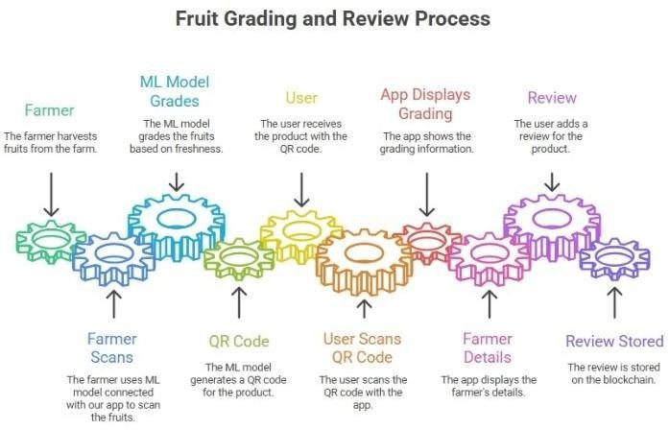

Fig. 1: Workflow of thefruit grading, QR traceability, and blockchain-based review system.

Model Training and Comparison

Transfer learning was applied through MobileNetV3 and EfficientNet with pre-trained ImageNet weights. The classification layers were omitted and added to accommodate

three levels of classification quality assessment: Grade A, Grade B, Grade C. Thereafter, multiple layers were re-trained to fit the apple-specific aesthetics (color consistency, surface smoothness, bruising). The training was conducted using learning rate scheduling, dropout, batch normalization and early stopping. For the precise evaluation of the performance of the models, precision, recall, and F1-score for the class in the dataset were also calculated. It helped to maintain the unbiased performance of the model for any specific grade class.
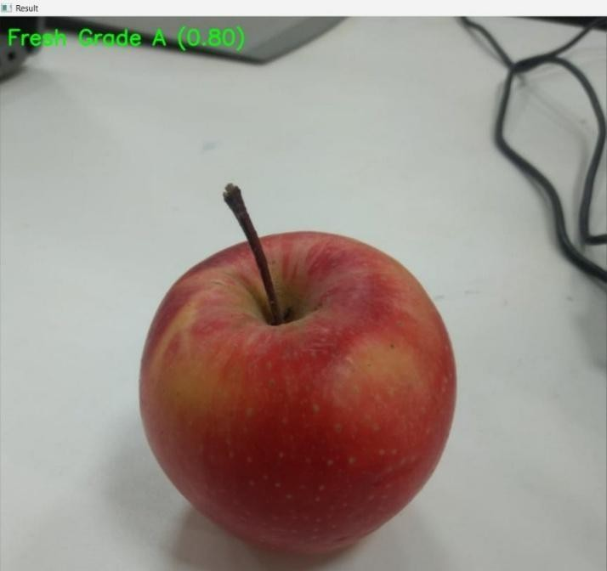

Figure 2: Model output demonstrating classification of the apple as Grade A with a confidence level of 0.80.

Real-Time Grading Workflow

The application of the suggested model translates to a mobile solution for on-field apple grading. The farmer snaps a photo or uploads an apple photo through the app, which preprocesses and infers in the background. The app presents the three grade probabilities while predicting quality within a few seconds so that farmers can receive fast, impartial grading without reliance on external parties in the field.
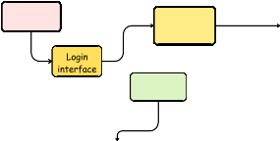

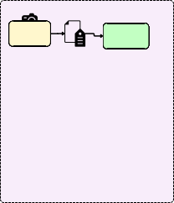

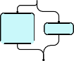




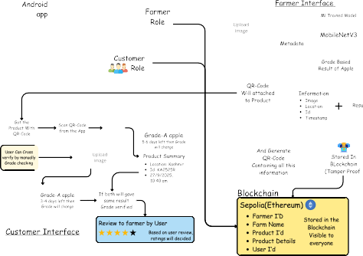


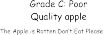

Fig. 3: System Architecture of the Proposed Apple Quality Grading and Traceability System.

Metadata Capture and Blockchain Storage

and transparency so that retroactive manipulation post-grading is avoided. All elements of the grading process are saved as metadata (who graded it, when it was graded, where it was graded—GPS coordinates) and the next step's secure, digitally structured file is sent to the blockchain-enabled decentralized ledger along with machine learning and confidence level for the generated grade.

QR-Based Traceability and Post-Harvest Support

Each graded lot is issued a unique QR code as well, connecting it to the blockchain transaction. Scanning the QR code allows anyone in the chain to validate the grading and source of the apples. Finally, a warehouse locater module integrates with the system's GPS to identify cold-storage warehouses and collection centers nearby for improved post-harvest decisions and reduced wastage.
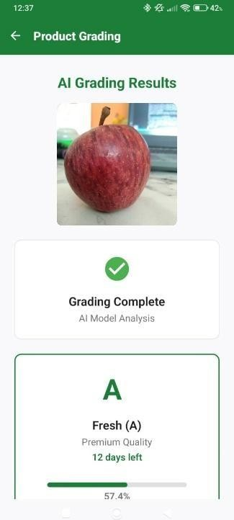
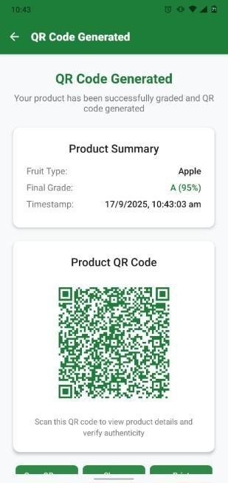

Figure 4 : AI-Based QR Code Generation Interface (right).
Figure 5: AI Grading Results Display with Fruit Quality Analysis (left).

System Integration

All modules are integrated into a unified mobile system. Lightweight processing occurs on the move, while blockchain processing is conducted in the cloud/edge services. This hybrid architecture favors low-latency, scalable and reliable operation in real-world agricultural scenarios.

Comparative Analysis Table

- Results and Discussions

Experiments have been conducted to evaluate the overall performance of the proposed automated apple grading system on model accuracy, blockchain traceability, QR-based verification, and warehouse locators. The results obtained prove that the integrated system enhances the reliability and transparency of the grading and post-harvest decisions in the entire apple supply chain.

Three image classification models, namely MobileNetV3, EfficientNet-B0, and ResNet50, have been trained on the apple- specific dataset. MobileNetV3 yielded the highest accuracy of 93%, in contrast to 90.8% from EfficientNet-B0 and 89.2% from ResNet50. It required very few training images at about 2,000 images per grade, while EfficientNet- B0 required more than 3,200 images and ResNet50 more than 4,000 images. MobileNetV3 also had the fastest inference time and hence was very suitable for real-time usage on smartphones. EfficientNet-B0 was good in terms of minor defect detection but ran slowly. ResNet50 had a heavy architecture; Therefore, it is not suitable for mobile deployment.

Factor | MobileNetV3 | EfficientNet-B0 | ResNet50
Accuracy | ≈93%  (Highest) | ≈90.8% | ≈89.2%
Images Required per Category | ~2000  (Lowest) | ~3000–3500 | ~4000+
Model Size | 5–6 MB  (Smallest) | 16–20 MB | 95–100 MB
Training Time | Fastest | Moderate | Slowest
Inference Speed (Mobile) | Very Fast | Fast | Slow
Computational Cost | Very Low | Low–Moderate | High
Suitability for Mobile Deployment | Excellent | Good | Poor
Generalization (Real Orchard Lighting) | Very Strong | Strong | Moderate
Ability to Detect Fine Defects | Strong | Strongest  (higher depth) | Moderate
Best Use Case | Real-time grading on smartphones | Cloud-based high-accuracy grading | Research / high-end GPU  processing

System | Primary Objecti ve | Key Strengths (Existing Work) | Major Limitatio ns (Compare d to  Proposed System) | Unique Contribution of Proposed System
Peng et al.  (SVM-  based grading) | Classify fruit grades via handcraf ted features | Low computati onal cost | No automatic feature learning; no digital traceabilit y; metadata editable | Automated DL based grading with tamper-proof metadata stored on blockchain.
Patel & Patil (CNN- SPP) | Detect fruit diseases | High lesion- detection accuracy | No grade classificati on; no secure storage; no consumer verificatio n | End-to-end grading (A/B/C) with immutable blockchain records accessible to all stakeholders.
Narvekar & Rao (Transfer Learning) | Multi- fruit grading | Strong feature extraction & accuracy | GPU-  dependent; no secure metadata; no manipulati on protection | Lightweight CPU-friendly model + blockchain ensures results cannot be altered post-grading.
Kona et al. (MobileNe tV2 Mango Defect Detection) | Detect surface defects | Mobile- friendly model | Only defect detection; lacks identity mapping; weak verificatio n flow | Each fruit assigned unique QR ID  + blockchain record, enabling multi-level verification (farmer→reta iler).
Hybrid MobileNet  / EfficientN et–SVM | Predict maturity | High maturity- prediction accuracy | No complete grading pipeline; metadata modifiable  ; no  supply- chain linkage | Full profiling (defects +  maturity + grade) stored immutably with distributed ledger consensus.
DenseNet Multi- fruit Model | High- accuracy grading | Strong representat ion learning | High computati onal load; unsuitable for edge  use; no trusted audit mechanis m | Real-time CPU/edge deployment + blockchain- backed audit trail for  transparent grading history.
ESP32  Hardware Grader | Low- cost physical sorting | Fast hardware response; affordable | Low image resolution; only local storage; vulnerable to tampering | AI grading combined with cloud- synced blockchain metadata for secure, high- resolution verification.
Blockchai n-based Traceabili ty (without object detection) | Supply- chain traceabil ity | Secure, transparen t transaction logs | Not linked to actual  AI grade prediction; lacks multi-level verificatio n workflow | Unified AI  grading + blockchain + QR  traceability pipeline with complete verification path.

Table 1: Comparative Study of Existing Fruit Grading Methods and the Proposed Integrated AI–Blockchain Solution

The standard deviation and variance of the model's performance were also analyzed.
Table 2: Performance Comparison of Deep Learning Models Used in the Proposed Apple Grading System

In addition to accuracy, precision, recall, F1-score was used to test the models. In this context, MobileNetV3 recorded a precision of 0.92, a recall of 0.91, and an F1-score of 0.915, which indicates a balance in the classification of all the grades. From the result of the confusion matrix, it is clear that Grade A apples are classified with the most accuracy, but some apples from Grade B and Grade C are confused with one another based on their surfaces.

In tests conducted on actual orchard floors, farmers clicked images of apples and got the results of grades within seconds, thereby establishing the usability of the system under variable lighting and field conditions. The blockchain module created each grading record with the identity of the farmer, timestamp, grade, and GPS location as an immutable entry to ensure traceability with no

tampering. QR codes

ensured that buyers and consumers accessed the verified provenance instantly. The warehouse locator also proved highly practical in identifying nearby cold-storage and collection centers, hence assuring less spoilage and better postharvest handling.

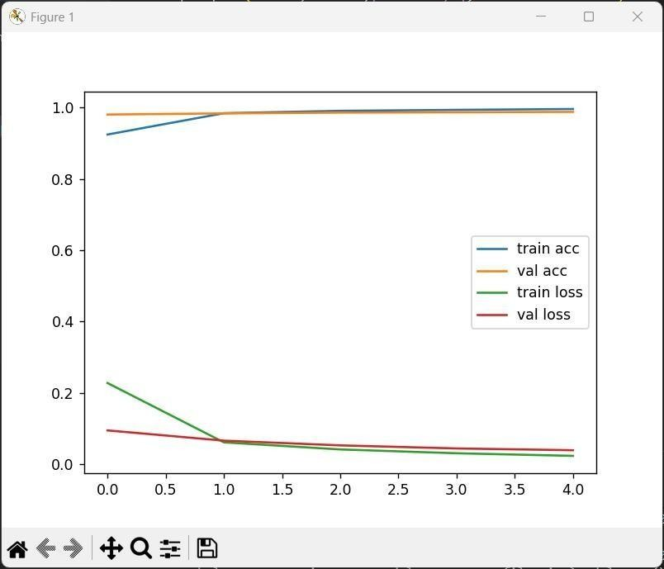

Fig. 6: Training and validation accuracy and loss curves of the fruit grading model.

Overall results, Therefore, confirm that MobileNetV3 was the best model for efficient and accurate performance. The effectiveness of the proposed system will lead to highly efficient apple traceability, quality control and distribution.

The statistical evaluation confirms not only the accuracy but also the consistency and reliability of the MobileNetV3 model for real-time applications in the agricultural environment.

FUTURE SCOPE

The new apple grading and traceability system could potentially be scaled up to tackle even bigger problems in the agricultural value chains and , Moreover, this system can also be extended to incorporate IoT technology in tracking the cold chain through temperature and humidity sensors to provide real-time tracking during storage and transportation. leading into the full export grade traceability of block chain and QR code systems that allow IoT international buyers to authenticate , where they buy their products from, how they are handled, and ensure better access to market for farmers.

The platform can be scaled even more for FPOs by incorporating intelligent logistics management for determining collection routes to reduce time lags and improve aggregation efficiencies. Furthermore, at a higher analytical level, farmers can gain insights from the platform, such as market rates, when to harvest and sell based on demand projections or when per kilo pricing will be favorable at the
end of the day. Ultimately, the grading component itself can be scaled to other fruits (oranges, bananas, mangoes, grapes) for a multi-fruit, multi-crop grading process at the farm gate. Therefore, with appropriate adaptations for imaging power, storage tracking and supply chain requirements, this could be a comprehensive digital agricultural platform for transparency, reduction of waste and increased price per kilo for farmers.

CONCLUSION

This paper reports on an automated apple grading system, a smart image-based classification system integrated with blockchain traceability and mobile decision-making support to increase apple supply chain trustworthiness. Of these, MobileNetV3 provided the highest accuracy with speed suitable for real-time use, trained to classify apples into standardized quality categories with higher precision. Results of grading along with all metadata like farmers' information, timestamp, and GPS location are recorded in a blockchain ledger with complete transparency and tamper evidence. Each lot of graded apples is associated with a unique QR code that would allow buyers/consumers to verify their authenticity and origin on the spot. It also helps the farmer by providing a warehouse locator for nearby cold storage and collection centers, hence reducing the chances of spoilage and enhancing post-harvest handling of the produce. In short, the solution has ensured consistency in apple grading, strengthened trust, and boosted efficiency across the value chain in the distribution of apples. The inclusion of statistical evaluation in the proposed system can further enhance its reliability.

ACKNOWLEDGMENT

The authors thank Vishwakarma Institute of Technology, Pune, for the resources and support provided. Thanks also go to all faculty members of the Department of Computer Science and Engineering-Artificial Intelligence and Machine Learning-for their valuable suggestions and guidance. Thanks are also due to fellow contributors who provided feedback and participated in discussions that greatly helped in refining and improving the method here presented.

REFERENCES

- J. Peng, J. Li, X. Li, L. Fang, P. Zhang, and Y. Lv, “Research on Image Recognition and Grading Method of Apple Based on Machine Vision,” in 2022 2nd International Conference on Computer Science, Electronic Information Engineering and Intelligent Control Technology (CEI), Nanjing, China, 2022, pp. 511–515.

- H. B. Patel and N. J. Patil, “Enhanced CNN for Fruit Disease Detection and Grading Classification Using SSDAE-SVM for Postharvest Fruits,” IEEE Sensors Journal, vol. 24, no. 5, pp. 6719–6732, 2024.

- C. Narvekar and M. Rao, “Fruit and Vegetable Grading with Transfer Learning and Convolutional Neural Networks for Better Productivity,” in 2023 International Conference on Advanced Computing Technologies and Applications (ICACTA), Mumbai, India, 2023, pp. 1–5.

- R. M. Math, N. V. Dharwadkar, V. Sajjanar, and M. N. Deshmukh, “Deep

Learning for Precision Grade-Quality Classification of Pomegranates,” in 2024 International Conference on Innovation and Novelty in Engineering and Technology (INNOVA), Vijayapura, India, 2024, pp. 1–6.

- S. Dutta, S. G. Neogi, D. Chanda, A. Pramanik, Ö. Girgin, and E. L. Öncül, “FruitQ-GradeX: Determining Fruit Quality and Grading with Explainable Deep Learning,” in 2025 12th International Conference on Reliability, Infocom Technologies and Optimization (ICRITO), Noida NCR, India, 2025, pp. 1–7.

- M. S. Morshed, S. Ahmed, T. Ahmed, M. U. Islam, and A. B. M. Ashikur Rahman, “Fruit Quality Assessment with Densely Connected Convolutional Neural Network,” in 2022 12th International Conference on Electrical and Computer Engineering (ICECE), Dhaka, Bangladesh, 2022, pp. 1–4.

- M. S. R. Kona, A. Guvvala, V. V. L. Eedara, M. S. Gowri, and V. Aluri, “Mango Fruit Defect Detection Using MobileNetV2,” in 2024 International Conference on Emerging Innovations and Advanced Computing (INNOCOMP), Sonipat, India, 2024, pp. 22–27.

- V. Agrawal, H. Barhate, H. Waghmare, K. Bhattad, and S. D. Shelke, “Fruit (Orange) Quality Inspection using Fully Convolutional Network,” in 2024 MIT Art, Design and Technology School of Computing International Conference (MITADTSoCiCon), Pune, India, 2024, pp. 1–6.

- C.-L. Chen and C.-Y. Chang, “Implementation of Apple Quality Automatic Classification System Based on Deep Learning Technique,” in 2025 IEEE International Conference on Consumer Electronics – Taiwan (ICCE-Taiwan), Kaohsiung, Taiwan, 2025, pp. 627–628.

- P. Singh, A. Rana, T. Choudhury, and N. Tripathi, “AI & ML-Based Smart Non-Disruptive Methods for Post-Harvest Fruit Grading: State-of-the- Art,” in 2024 MIT Art, Design and Technology School of Computing International Conference (MITADTSoCiCon), Pune, India, 2024, pp. 1–6.

- K. Ahmed, Kajal, M. K. Dubey, and D. K. Pandey, “Machine Learning Enabled System Architecture for Automatic Grading and Sorting of Walnut Fruits: A Review,” in 2024 International Conference on Electrical Electronics and Computing Technologies (ICEECT), Greater Noida, India, 2024, pp. 1– 6.

- N. Kundu, Sonam, G. Rani, and V. S. Dhaka, “A Deep Learning Based System for Automatic Sorting and Quality Grading of Citrus Fruits,” in 2024 International Conference on Emerging Trends in Networks and Computer Communications (ETNCC), Windhoek, Namibia, 2024, pp. 1–5.

- N. E and V. G, “Convolutional Neural Network-Based Multi-Fruit Classification and Quality Grading with a Gradio Interface,” in 2024 International Conference on Innovative Computing, Intelligent Communication and Smart Electrical Systems (ICSES), Chennai, India, 2024, pp. 1–7.

- K. Dakwala, V. Shelke, P. Bhagwat, and A. M. Bagade, “Evaluating Performances of Various CNN Architectures for Multi-Class Classification of Rotten Fruits,” in 2022 Sardar Patel International Conference on Industry 4.0, Mumbai, India, 2022, pp. 1–4.

- L. Yi and J. Zhong, “Apple Grade Classification Based on Convolutional Neural Network and Machine Learning,” in 2024 International Conference on Neuromorphic Computing (ICNC), Chongqing, China, 2024, pp. 1–5.

